Experiment 19: steering gear control experiment

Steering gear is a kind of position servo drive, is mainly composed of a casing, a circuit board, non - core motor, gear and position detector. Its working principle is by the receiver or the SCM sends signals to the servo and the internal have a benchmark circuit, generating cycle for 20ms, width of 1.5ms reference signal, will get the DC bias voltage and the potentiometer voltage compared with that obtained from the voltage difference output. Through the IC circuit board judge the direction of rotation, and then drive - core motor starts to rotate, through the reduction gear, the power is transmitted to the swing arm, also by a position detector back to signal, judge whether it has already reached the location. It is suitable for the The control system which needs to be changed and can be kept in a certain degree. When the motor speed is certain, the potentiometer is rotated by a cascade speed reduction gear, the voltage difference is 0, the motor stops rotating, and the angle range of the general steering gear rotation is 0 degrees to 180 degrees.
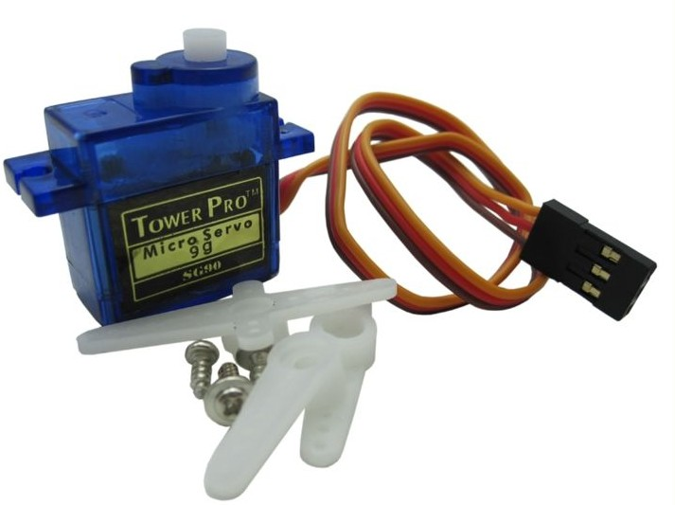
Servo there are many specifications, but all the steering gear has an external three lines, respectively, with brown, red, orange three colors to distinguish, because the steering gear brand is different, the color will be different, brown for the ground wire, red for the positive wire, orange signal line.
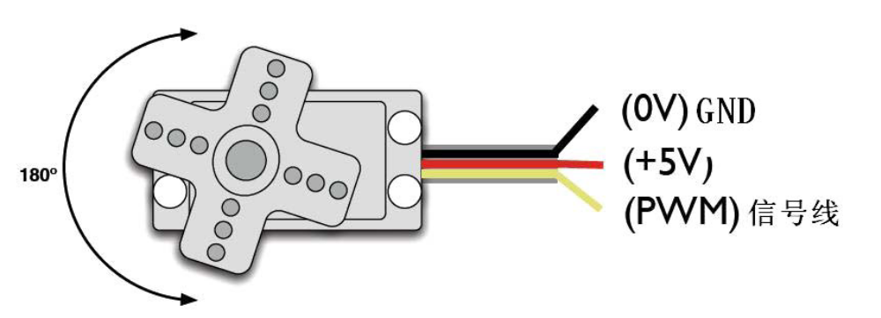
Steering angle is adjusted PWM (pulse width modulation) signal duty cycle to achieve, standard PWM (pulse width modulation) signal cycle is fixed to 20ms (50Hz), pulse width distribution should be between 1ms to 2ms, but in fact pulse width can be from 0.5ms to 2.5ms, pulse width and steering angle of 0 degrees to 180 degrees. There is a point worth noting, because the steering gear brand is different, for the same signal, different brands of steering angle will be different.
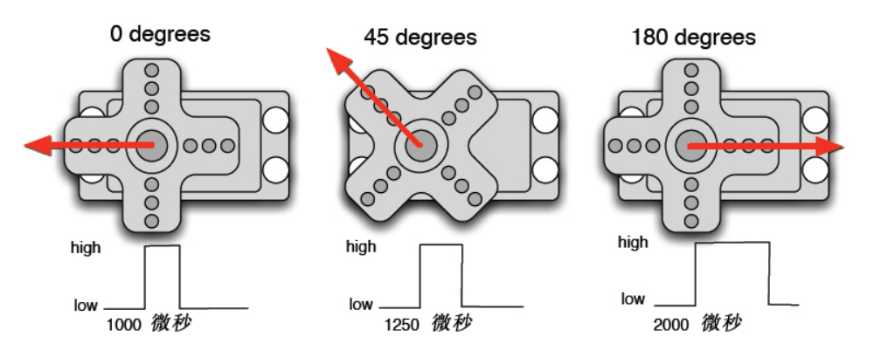
After knowing the basic knowledge we can learn to control a servo motor, components of the experiments required rarely need only steering gear A and a jumper bar can be.。
RB - 412 steering gear *1

Bread board jumper *1 tie
The steering gear with Arduino method has two kinds, one is through the Arduino common digital sensor interface to produce a different duty cycle of Fang Bo, analog PWM signal steering, second is the direct use of Servo function Arduino function for steering control, the advantages of this control method is to control the 2 way steering gear, because the Arduino comes with a function only the use of digital 9,10 interface.Arduino drive ability is limited, need to control more than 1 of the steering gear The source.。
One method
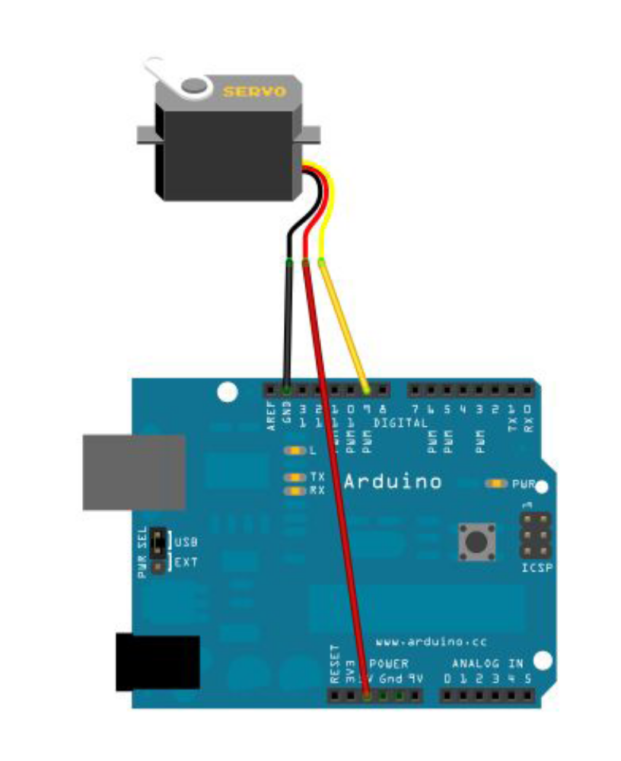
The steering gear is connected to the digital 9 interface.

Write a program to turn the steering gear to the user input number corresponding to the number of degrees of the position, and the angle of the print display to the screen.
Reference to source program A:、
Int servopin=9; / / define digital interface 9 connected servo signal line

Int myangle; / / define the angle variable

Int pulsewidth; / / define variable pulse widthint val;
void servopulse(int servopin,int myangle)//Define a pulse function
{
pulsewidth=(myangle*11)+500;//The pulse width of 500-2480 is converted into the pulse width.
digitalWrite(servopin,HIGH);//The rudder interface level is high
delayMicroseconds(pulsewidth);//Time delay pulse width
digitalWrite(servopin,LOW);//Servo interface level to low
delay(20-pulsewidth/1000);
}
void setup()
{
pinMode(servopin,OUTPUT);//Set steering interface for output interface
Serial.begin(9600);//Connected to the serial port, the baud rate is 9600
Serial.println("servo=o_seral_simple ready" ) ;
}
void loop()//The number of 0 to 0 is converted to a 9 - to 180 angle, and the number of the corresponding number of LED flashes
{
val=Serial.read();//Read the value of the serial port
if(val>'0'&&val<='9')
{
Val=val-'0'; / / the features into numerical variables

Val=val* (180/9); / / digital into perspective
Serial.print("moving servo to ");
Serial.print(val,DEC);
Serial.println();
for(int i=0;i<=50;i++) //Give the steering gear enough time to let it go to the specified angle.
{
servopulse(servopin,val);//Reference pulse function
}
}
}
Method two
First detailed analysis of the Arduino comes with the Servo function and its statements, to introduce some of the common statements of the rudder function.
- attach(Interface) - to set the steering gear interface, only the number 9 or 10 interface can be used.
- Write (angle) - to set the steering angle of the steering angle of the steering gear can be set from the angle range is 0 degrees to 180 degrees.
- Read () - a statement that reads the steering angle of the steering gear can be understood as the value of the last write () command.
- attached（）——To determine whether the steering gear parameters have been sent to the actuator interface。
5、detach（）——The steering gear is separated from its interface, and the interface (number 9 or 10) can continue to be used as a PWM interface.。
Note: the above statement is written in the format of the actuator variable name. The specific statement (), for example: myservo.attach (9).
The steering gear is still connected to the digital 9 interface.Reference to source program B:
<Servo.h>// #include header files, there is a point to pay attention, you can directly in the Arduino software menu bar click Sketch>Importlibrary>Servo, call the Servo function, you can directly enter the <Servo.h> #include, but in the input should pay attention to between #include and <Servo.h> to have a space, or compile time will be reported to the wrong.
Servo myservo; / / define servo variable name
void setup()
{
myservo.attach(9);//Definition of steering gear interface (9,10 can, shortcomings can only control 2)
}
void loop()
{
myservo.write(90);//Set the steering angle of the steering gear.
}
Above is to control the steering gear of the two methods, each has its own advantages and disadvantages of each according to their own preferences and needs to be chosen.

